# **TRUCKS ROUTE OPTIMIZATION FOR LIQUOR COMPANY**

# **About Company**

Hero of Liquor is a small-scale wholesaler of liquor, wine and alcohol distributor located in Taichung, Taiwan. This is a family business run by the parents of Hsin-Ting Wang (our classmate in Cohort B). Every day, the company purchases products directly from the manufacturers, transports the products to their home location where they maintain a single inventory and distribute these products to its retailers (customers) based on daily demand using their 8 owned trucks. All the company’s customers/retailers which are basically small liquor shops, are divided into 3 regions of Taiwan – North, Middle and South Region.

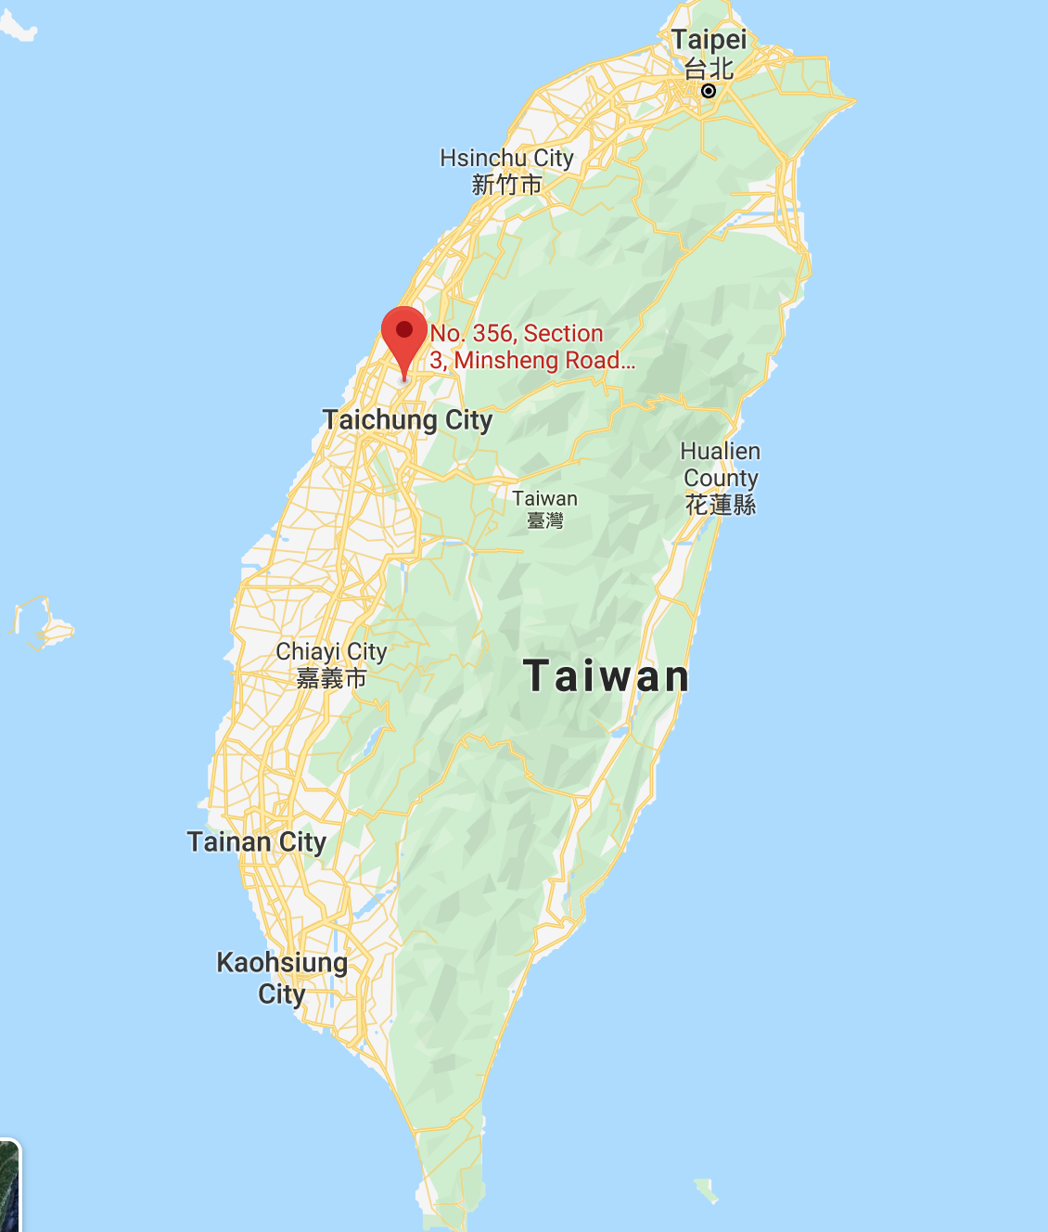

**Hero of Liquor**

# **Problem description**

Each day, the company has to decide the route for sending trucks out to deliver products to retailers based on the demand for each retailer. The company currently does not have any optimization engine to help them in deciding an optimal route. As of now, drivers use their experiences and gut feelings to decide their route for the day. We found this opportunity for improvement where we can add value by using our mathematical modeling skills to create a model which can decide an optimal route for each truck so that the demand for all retailers is met by covering least distance.

Following table shows important numbers about company:

|  |  |  |
| --- | --- | --- |
| **Region** | **# of retailers** | **Demand per day (# of boxes)** |
| North | 21 | 120 |
| Middle | 14 | 80 |
| South | 14 | 80 |

From the optimization model of team -5, we got to know that 7 trucks with capacity of 40 boxes are required for meeting the demand of these retailers on a certain day. Hence, we have used 7 trucks for our problem. There is also a constraint that each truck has to start from the home location and come back to this home location at the end of the day.

# **Algorithm Used**

Since this problem is similar to multiple traveling salesperson problem, we are using a genetic algorithm which is a metaheuristic algorithm and belongs to a larger class of evolutionary algorithm which means that these algorithms are dynamic and evolve over time. Genetic algorithm works on a population consisting of solutions and each solution has chromosome which is defined by certain parameters. Based on how each individual solution is performing, best performing individuals are selected and mutated further to get optimal answer. We have solved our problem using evolutionary solver in excel.

# **Data Collection/Input Parameters**

We approached Hsin-Ting Wang in order to get information about the location of each retailer and the demand for each retailer on a certain day.

1. We were provided with google location for all the 49 locations of retailers and home location as shown below:

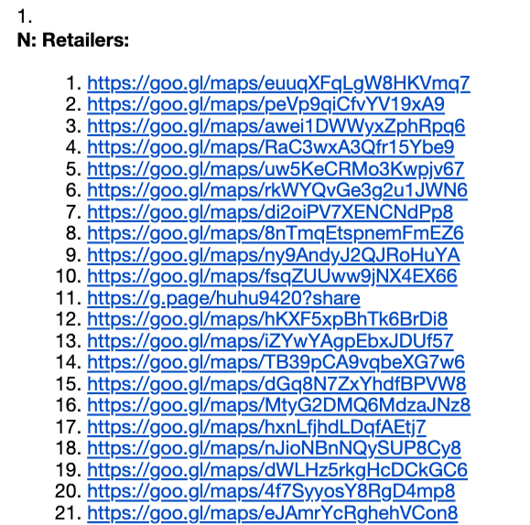 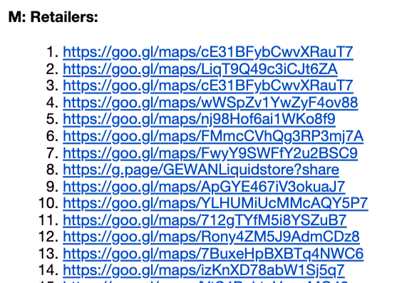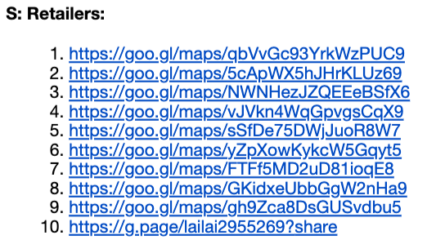

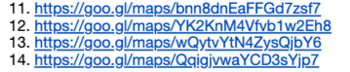

Using these google locations, we created distance matrix (in miles) by using google maps for 50*50 combinations as shown below:

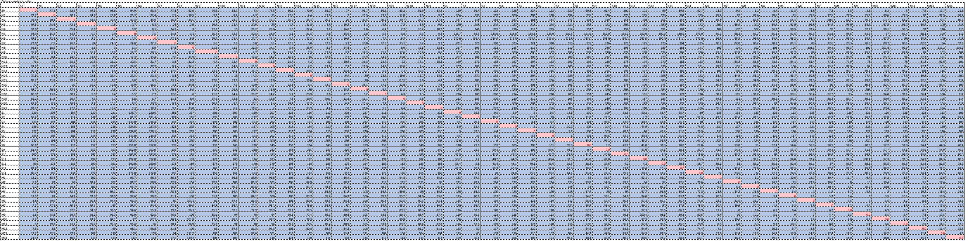

1. Demand matrix

|  |  |  |
| --- | --- | --- |
| **City** | **Index** | **Demand ( # of boxes)** |
| SP | 0 |  |
| N1 | 1 | 6 |
| N2 | 2 | 10 |
| N3 | 3 | 8 |
| N4 | 4 | 8 |
| N5 | 5 | 5 |
| N6 | 6 | 4 |
| N7 | 7 | 8 |
| N8 | 8 | 3 |
| N9 | 9 | 2 |
| N10 | 10 | 9 |
| N11 | 11 | 4 |
| N12 | 12 | 8 |
| N13 | 13 | 10 |
| N14 | 14 | 6 |
| N15 | 15 | 5 |
| N16 | 16 | 3 |
| N17 | 17 | 4 |
| N18 | 18 | 4 |
| N19 | 19 | 5 |
| N20 | 20 | 3 |
| N21 | 21 | 5 |
| S1 | 22 | 6 |
| S2 | 23 | 5 |
| S3 | 24 | 7 |
| S4 | 25 | 4 |
| S5 | 26 | 8 |
| S6 | 27 | 1 |
| S7 | 28 | 9 |
| S8 | 29 | 8 |
| S9 | 30 | 5 |
| S10 | 31 | 6 |
| S11 | 32 | 4 |
| S12 | 33 | 7 |
| S13 | 34 | 2 |
| S14 | 35 | 8 |
| M1 | 36 | 7 |
| M2 | 37 | 8 |
| M3 | 38 | 10 |
| M4 | 39 | 5 |
| M5 | 40 | 6 |
| M6 | 41 | 2 |
| M7 | 42 | 8 |
| M8 | 43 | 6 |
| M9 | 44 | 6 |
| M10 | 45 | 4 |
| M11 | 46 | 8 |
| M12 | 47 | 4 |
| M13 | 48 | 3 |
| M14 | 49 | 3 |

# **Mathematical model setup**

**Input parameters:**

Dij = Distance matrix with distance in miles from retailer location i to retailer location j where i, j ε [ 0,1,2, …… 49] where 0 is Starting point and 1-49 are the 49 retailer locations

Si = Products required by retailer i on a certain day where i ε [ 1,2, …… 49] where 1-49 are the 49 retailer locations

M = Maximum capacity of truck

**Decision Variable:**

Xkm = Which city to visit in step k and for truck m where k ε [ 1,2, …7] and m ε [ 1,2, …7] as each truck can visit to 7 locations and there are 7 trucks

**Objective Function:**

 Minimize total distance travelled by all trucks

Total distance = $Min( \sum_{m}{[}\sum_{k}{}$ D(Xkm , Xk-1m )])

where k is the position in each route k ε [ 1,2, …7] and m is the truck number m ε [ 1,2, …7] as each truck can visit to 7 locations and there are 7 trucks

**Constraints:**

1. All values in step should be different

Xkm is not equal to Xnt for any km not equal to nt for all k,m,n,t truck number m,t ε [ 1,2, …7]

1. Xkm is integer
2. Xkm. >=1
3. Xkm. <=49
4. Truck capacity constraint

$\sum_{k}{}$ S(Xkm ) <= M for all m ε [ 1,2, …7]

# **Excel file**

**Decision Variable:**

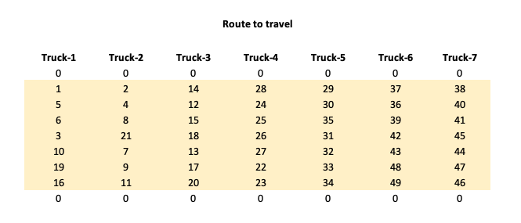

**Objective function:**

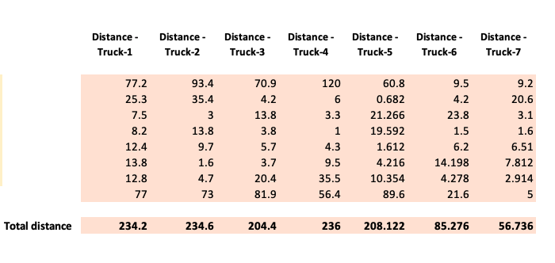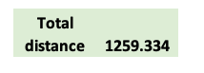

**Constraints:**

All different constraint

 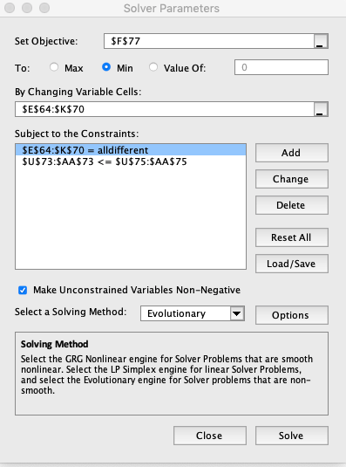

Truck Capacity

**

# **Please find attached excel file:**

# **Results**

Company’s current route plan for trucks gives a total distance of 1439.69 miles as shown below:

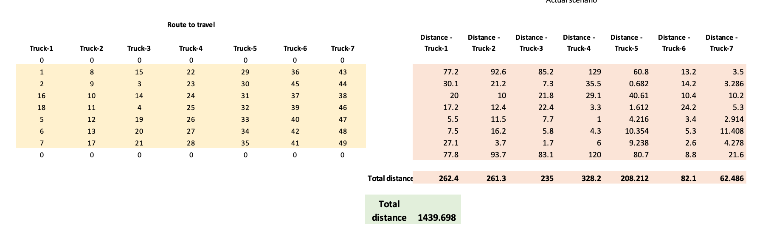

Optimized route plan using genetic algorithm gives the following route with total distance of 1259.33 miles while fulfilling the truck capacity constraint:

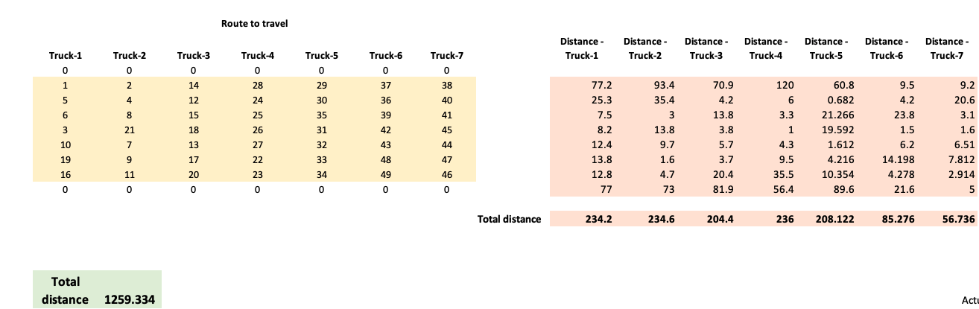

# The solver has accurately assigned retailers according to region even without explicitly telling solver about regions. The same is shown below:

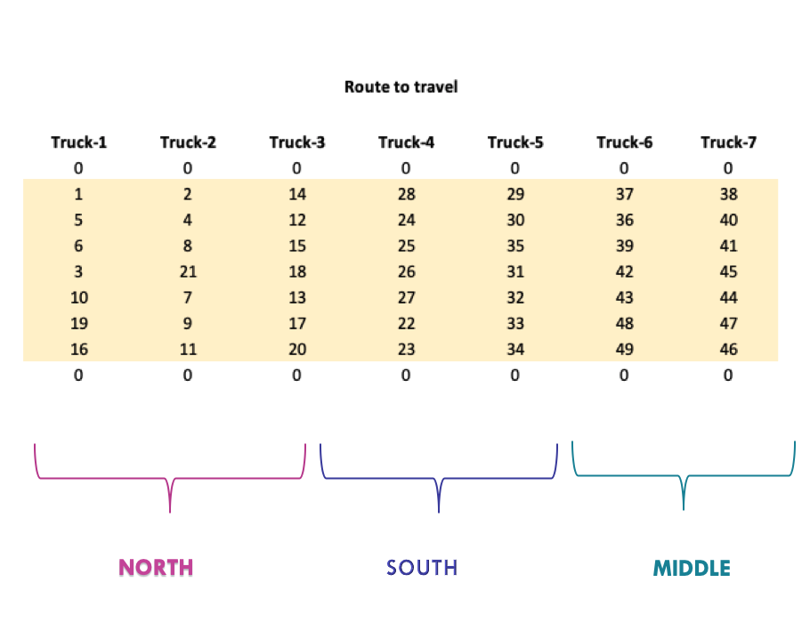

# We also got the current route followed by trucks during a certain day from company and following shows comparison between two routes:

**Truck – 1 – Current Route Truck – 1 – Optimal Route**

Total distance – 234.2 miles

Total distance –262.4 miles

**Truck – 2 – Current Route Truck – 2 – Optimal Route**

Total distance –234.6 miles

Total distance –261.3 miles

**Truck – 3 – Current Route Truck – 3 – Optimal Route**

**

Total distance –204.4 miles

Total distance –235.3 miles

**Truck – 4 – Current Route Truck – 4 – Optimal Route**

Total distance –328.2 miles

Total distance –236 miles

**Truck – 5 – Current Route Truck – 5 – Optimal Route**

Total distance –208.2 miles

Total distance –208.1 miles

**Truck – 6 – Current Route Truck – 6 – Optimal Route**

Total distance –85.3 miles

Total distance –82.1 miles

As can be seen from route of truck 6, current route is more optimal than the route given by our model. This is happening because solver is trying to minimize overall distance travelled by all 7 trucks.

**Truck – 7 – Current Route Truck – 7– Optimal Route**

Total distance –62.5 miles

Total distance –56.7 miles

# **Findings and recommendations**

It is extremely difficult to just look at so many locations and decide which route would be the best. Hence, an optimization model like this can help the company in everyday planning. Although genetic algorithm does not guarantee the optimal answer, it can still give answers very close to the optimal solution and on top of this solution, drivers can use their experience to make it more optimal.

Company should use this model every day to decide the optimal route for each truck and save a lot in their transportation cost.